Practical No.1D
Create a web application to find addition of a two number using Simple SOAP service Server Side
Server-Side Code:--
package Server;
import javax.jws.WebService;
import javax.jws.WebMethod;
import javax.jws.WebParam;
@WebService(serviceName = "Two_Num_Amin_6010")
public class Two_Num_Amin_6010 {
@WebMethod(operationName = "Addition")
public double Addition(@WebParam(name = "n1") double n1, @WebParam(name = "n2") double n2) {
//TODO write your implementation code here:
return n1+n2;
} }
Server-Side Output:-
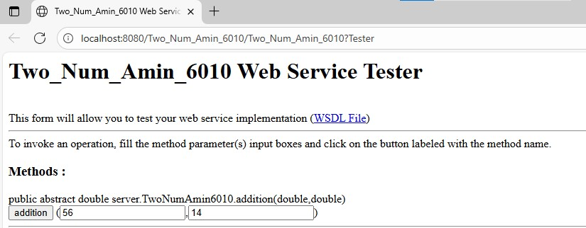
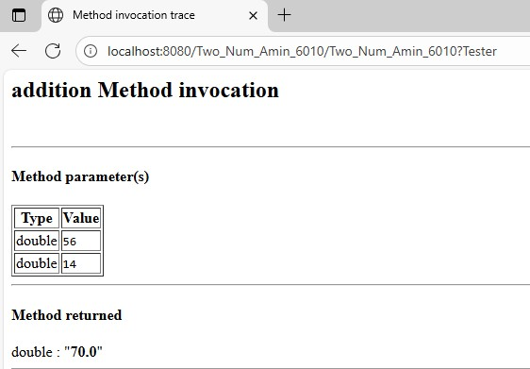
Client-Side Code:-
Input.jsp:-
%@page contentType="text/html" pageEncoding="UTF-8"%>
<!DOCTYPE html>
<html>
<head>
<meta http-equiv="Content-Type" content="text/html; charset=UTF-8">
<title>Practical-1.D</title>
</head>
<body>
<h1>Amin Patel TYCS 6010</h1>
<form action="output.jsp" method="POST">
Enter First Number : <input type="text" name="t1" value="" />
<br><br>
Enter Second Number: <input type="text" name="t2" value="" />
<br><br>
<input type="submit" value="Submit" />
</form>
</body>
</html>

Output.jsp

<%@page contentType="text/html" pageEncoding="UTF-8"%>
<!DOCTYPE html>
<html>
<head>
<meta http-equiv="Content-Type" content="text/html; charset=UTF-8">
<title>JSP Page</title>
</head>
<body>
<h1>Amin Patel TYCS 6010</h1> <%-- start web service invocation --%><hr/>
<%
try {
server.TwoNumAmin6010_Service service = new server.TwoNumAmin6010_Service();
server.TwoNumAmin6010 port = service.getTwoNumAmin6010Port();
// TODO initialize WS operation arguments here
double n1 = Integer.parseInt(request.getParameter("t1"));
double n2 = Integer.parseInt(request.getParameter("t2"));
// TODO process result here
double result = port.addition(n1, n2);
out.println("Addition = "+result);
} catch (Exception ex) {
// TODO handle custom exceptions here
}
%>
<%-- end web service invocation --%><hr/>

</body>
</html>

Client-Side Output:-

